Microsoft Office 365
Login and Document Sharing
Logging in and sharing documents in Office 365 is easy. Why do you need to do it?
- USB drives are not allowed in most areas of Ferris High School.
- By the end of the year, you will no longer have a student drive.
- Some of your teachers may require sharing documents with them through the program.
Logging into Office 365
On your desktop/laptop/tablet, there is a shortcut to Office 365. If you are at home, you MUST access 365 through the spokaneschools.org website. If you google 365, you will not have access to your account.
This is the shortcut on your desktop:
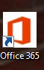
You will arrive at the login page.
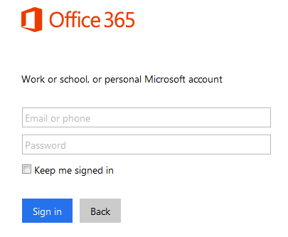
Login:
Username: Smith1234@sps81.org
Password: Eight (8) digit birthdate.

Now, go to OneDrive to access your files.
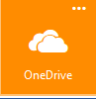
Click and you will see all of your files.
Sharing
Open the file you want to share. You can share any file. In the upper right hand corner of your screen, you will see a blue or gray button with a person.
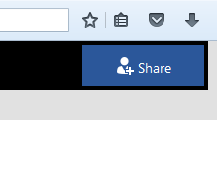
Click on that button. A box will pop up directing you to invite a person. You can invite any student or teacher at Ferris. Be sure to write a brief message with the file you are sharing. You need to know the first and last name of whoever you want to invite. Yes, your teachers have first names. Be sure that your document allows editing.
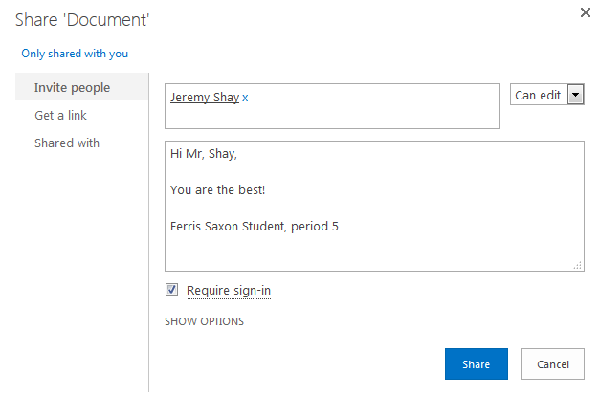
Once you click on the blue “Share” button, your document has been sent.
If you have any questions on this process, ask a friend or feel free to see Mrs. Ellerd in the library.
If, at any time, you need to return to your files or another 365 function, go to the upper left hand corner to access the waffle.
(That is the waffle.)
Congratulations, you are well on your way to mastering Microsoft 365.

